Case 14-AM,C-Costa Rica-Guanacaste, Nicoya-Female Effigy-200 BCE-200 CE.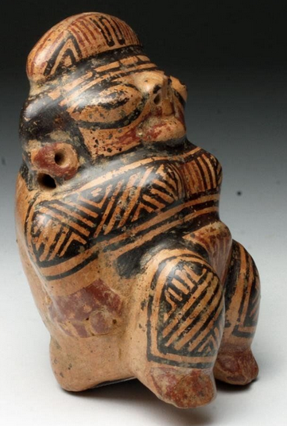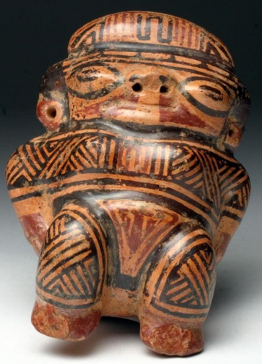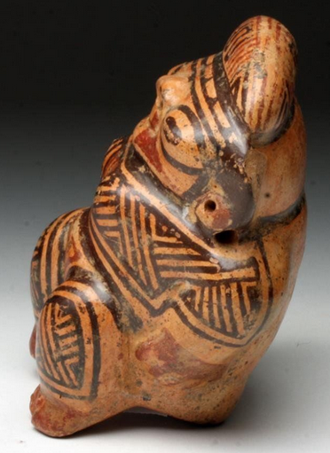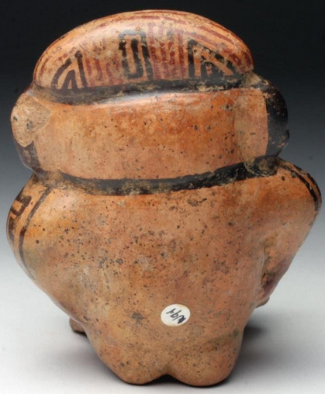

**Formal Label:** Guanacaste, Nicoya Ceramic Female Effigy-ca. 200 BCE - 200 CE.

**Accession Number:** [F1545.3.P6](http://luna.wellesley.edu/search%7ES1?/mF1545.3.P6+C67+1988/mf++1545.3+p6+c67+1988/-3,-1,,B/browse)

Display Description: Human habitation of the Greater Nicoya region of southwestern Nicaragua and northwestern Costa Rica extends back in time to the Paleo-Indian period (about 10,000 B.C.), as evidenced by a fluted spearpoint (Snarskis 1981a, 25). Settled human life, probably coinciding with the beginnings of agriculture, began by around 1000 B.C. By 500 B.C. the region's inhabitants had initiated what was to become a 2,000-year tradition of producing artistically excellent ceramics. While plain, utilitarian pottery was always made for food cooking and storage, clay was also used extensively as an expressive artistic medium. Vessels, figures, and musical instruments were manufactured (generally using the coiling method), then decorated with modeling, carving, punctation (repeated indentations), and slip painting.

Firing was usually accomplished by placing the fully dry wares in a slight depression on the ground, then piling fuel over and around them. The relatively low firing temperatures achieved with this method produced earthenware, which is somewhat soft and porous. In some styles, additional decoration (such as incision, scorching, or smoking) was applied after firing. Some of the earliest ceramics (such as Rosales Zoned Engraved) are highly sophisticated, combining sculptural forms with surfaces decorated with carved or incised outlines filled with contrasting slip colors. Throughout the centuries, ceramicists in the region fully explored clay's decorative possibilities, producing solid-colored jars or vessels in the shape of animals or humans (effigy vessels) adorned with linear designs or texturing; spectacular, profusely modeled incense burners with cut-out openings; and beautifully painted polychrome (multicolored) bowls, jars, and figures with smoothly polished surfaces.

From about A.D. 1 to 500, high-status grave offerings in the Greater Nicoya region incorporate finely crafted grave goods, including decorative ceramics like this one as an accompaniment to the deceased.

**Date or Time Horizon:** 200 BCE - 200 CE.

**Geographical Area:** Guanacaste-Nicoya, Costa Rica-Nicaragua

**Map:**

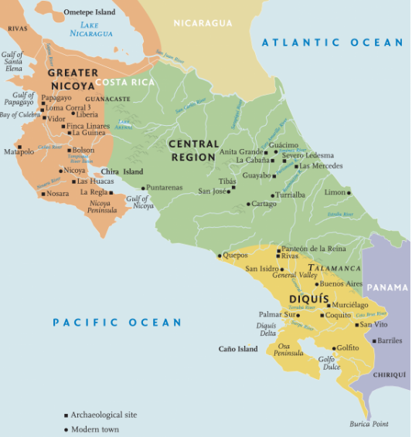

The Nicoya culture area in ancient Costa Rica after https://denverartmuseum.org/article/ancient-costa-rica

**Cultural Affiliation:** Guanacaste-Nicoya

**Medium:** Terracotta

**Dimensions:** H: 4 1/3 in, W: 3 ½ in, D: 2 ½ in

**Weight:** Weight: 10.2 oz.

**Provenance:** Ex-Gilbert Martin Collection, Georgia, USA; Ex-Artemis Gallery

**Condition:** Excellent condition.  Has one chip on back of left ear and does not affect visual appearance.

**Discussion:** This female effigy possesses the elegant styling of the Guanacaste-Nicoya artisan. Produced with a striking trichromatic style in red and black on cream ground, it has a high-gloss burnished finish demonstrating fine technique. The entire surface is ornately decorated with flowing geometric patterns adorning her headdress, body, and costume accentuating the curves of her body. Black spotting particularly visible on backside represents manganese oxide deposits that develop with prolonged burial. This female effigy was most likely placed in a grave to grant the inhabitant rebirth in the afterlife.

**References:**

**Lange, Frederick W. 1988. *Costa Rican art and archaeology : essays in honor of Frederick R. Mayer.*** [Boulder, Colo.] : University of Colorado.

### ****Clifford, Paul. 1985. *Art of Costa Rica: Pre-Columbian painted and sculpted ceramics from the Arthur M. Sackler collections*, edited by Lois Katz.**** Washington, D.C.: Arthur M. Sackler Foundation: AMS Foundation for the Arts, Sciences and Humanities.